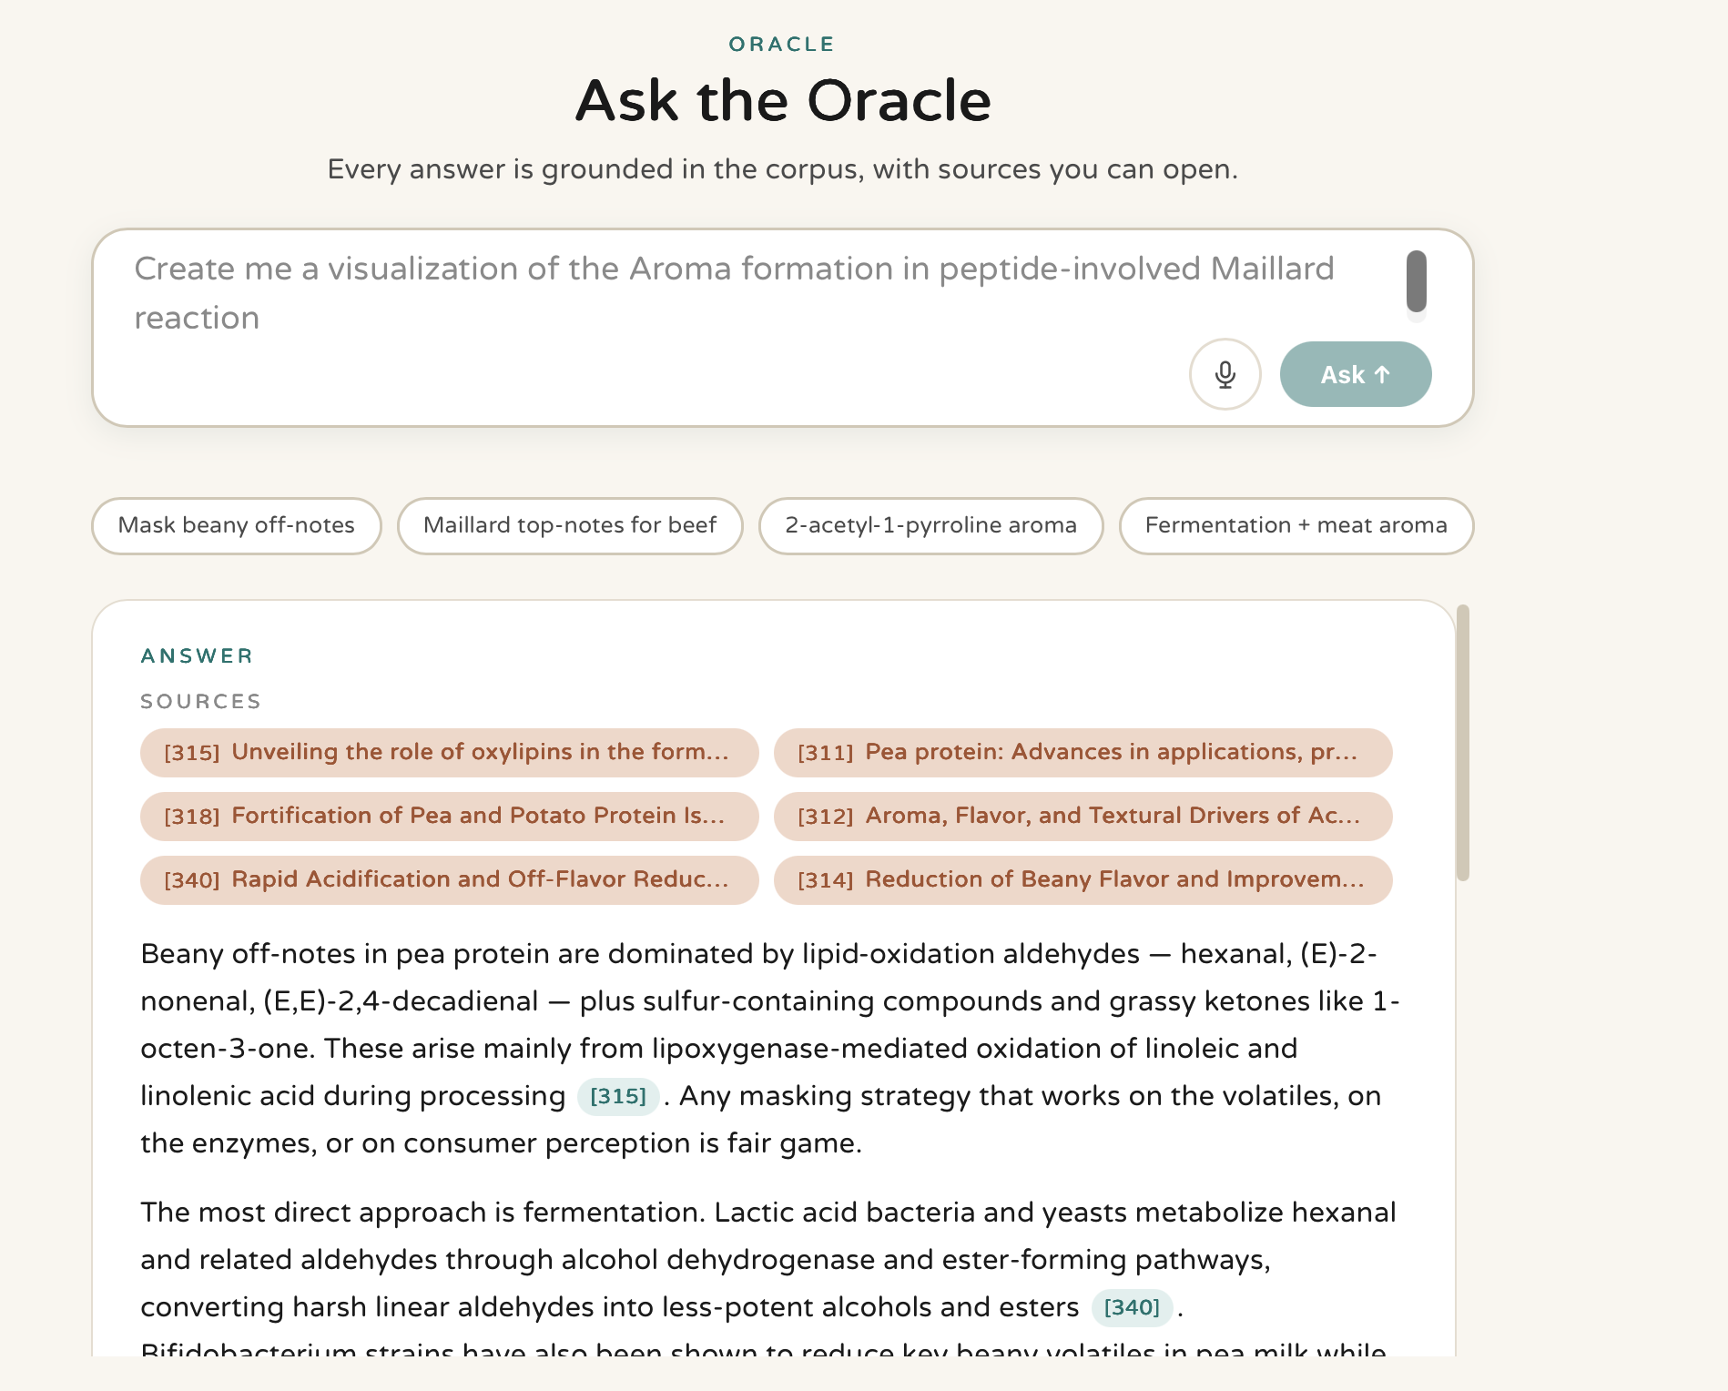
“Every answer is based on a closed corpus with information you can access
Delete this
The clickable buttons should be of quick suggestions to show the power of the oracle , for example: maillard synthesis route

No need for this gap, its better to have more room for the oracle answer

1.sources need to be at the end of answer
2.in blue palette color, show 2 with the option to expand

No need for scrolling in input chat text
shorter sentence so it won’t need two lines

